# Getting Started

An example script is provided for the white beam flower (*white_beam_flower_example.py)* and the AM cube data *(am_cubes_example.py*) in the **NxTomoWriter** folder on the desktop. To run an example, do the following:

1. Open the folder that contains the examples in the File Explorer

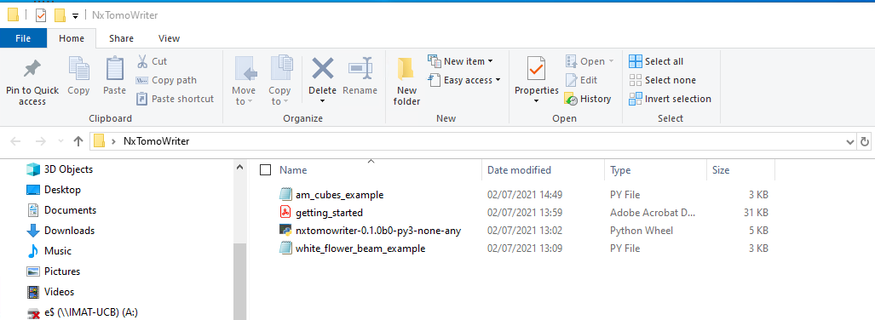

1. Open the command prompt in that folder by typing “CMD” in the address bar and pressing enter.

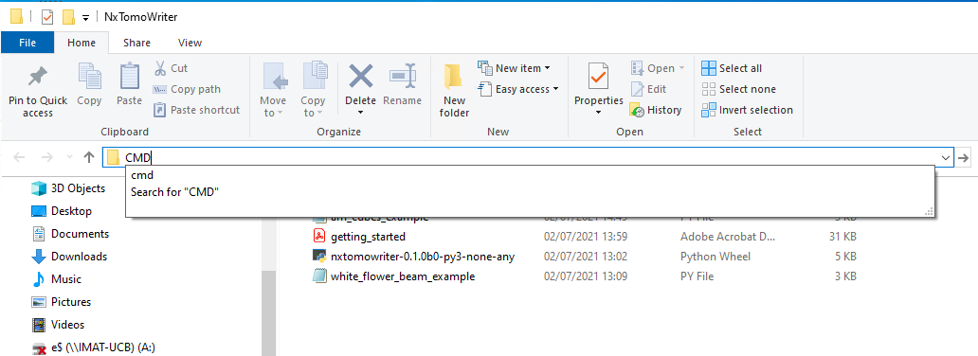

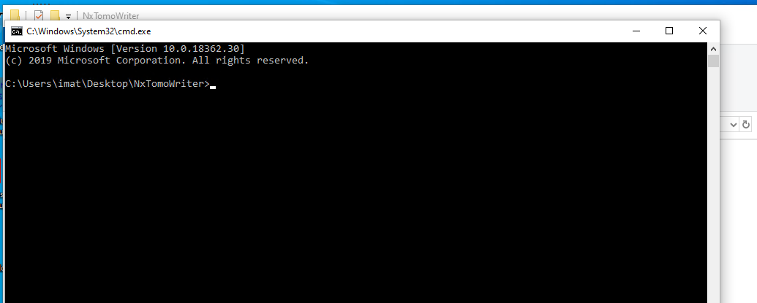

1. In the command prompt, type "python <python script>" e.g "python am_cube_example.py" and press enter.

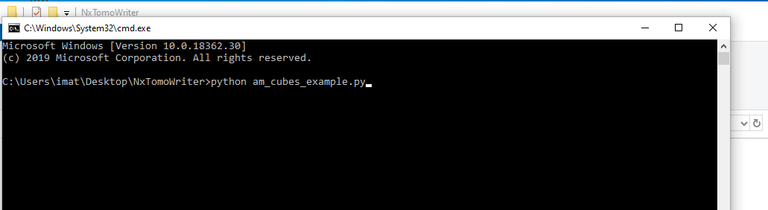

1. The script should run and complete as show below

